**DAILY ONLINE ACTIVITIES SUMMARY**

|  |  |  |  |  |  |  |  |  |
| --- | --- | --- | --- | --- | --- | --- | --- | --- |
| **Date:** | **06-06-2020** | | | | | **Name:** | **JAYANTH SV** | |
| **Sem & Sec** | **VIII Semester & A Section** | | | | | **USN:** | **4AL16CS041** | |
| **Online Test Summary** | | | | | | | | |
| **Subject** | | **IOT** | | | | | | |
| **Max. Marks** | | **30** | | **Score** | | | **30** | |
| **Certification Course Summary** | | | | | | | | |
| **Course** | **Introduction to Ethical Hacking** | | | | | | | |
| **Certificate Provider** | | | **Great Learning** | | **Duration** | | | **6 Hours** |
| **Coding Challenges** | | | | | | | | |
| **Problem Statement: Write a program in C to rotate an array by N positions** | | | | | | | | |
| **Status: COMPLETED** | | | | | | | | |
| **Uploaded the report in Github** | | | | | **YES** | | | |
| **If yes Repository name** | | | | | **Jayanth-Sv** | | | |
| **Uploaded the report in slack** | | | | | **YES** | | | |

Online Test Details:

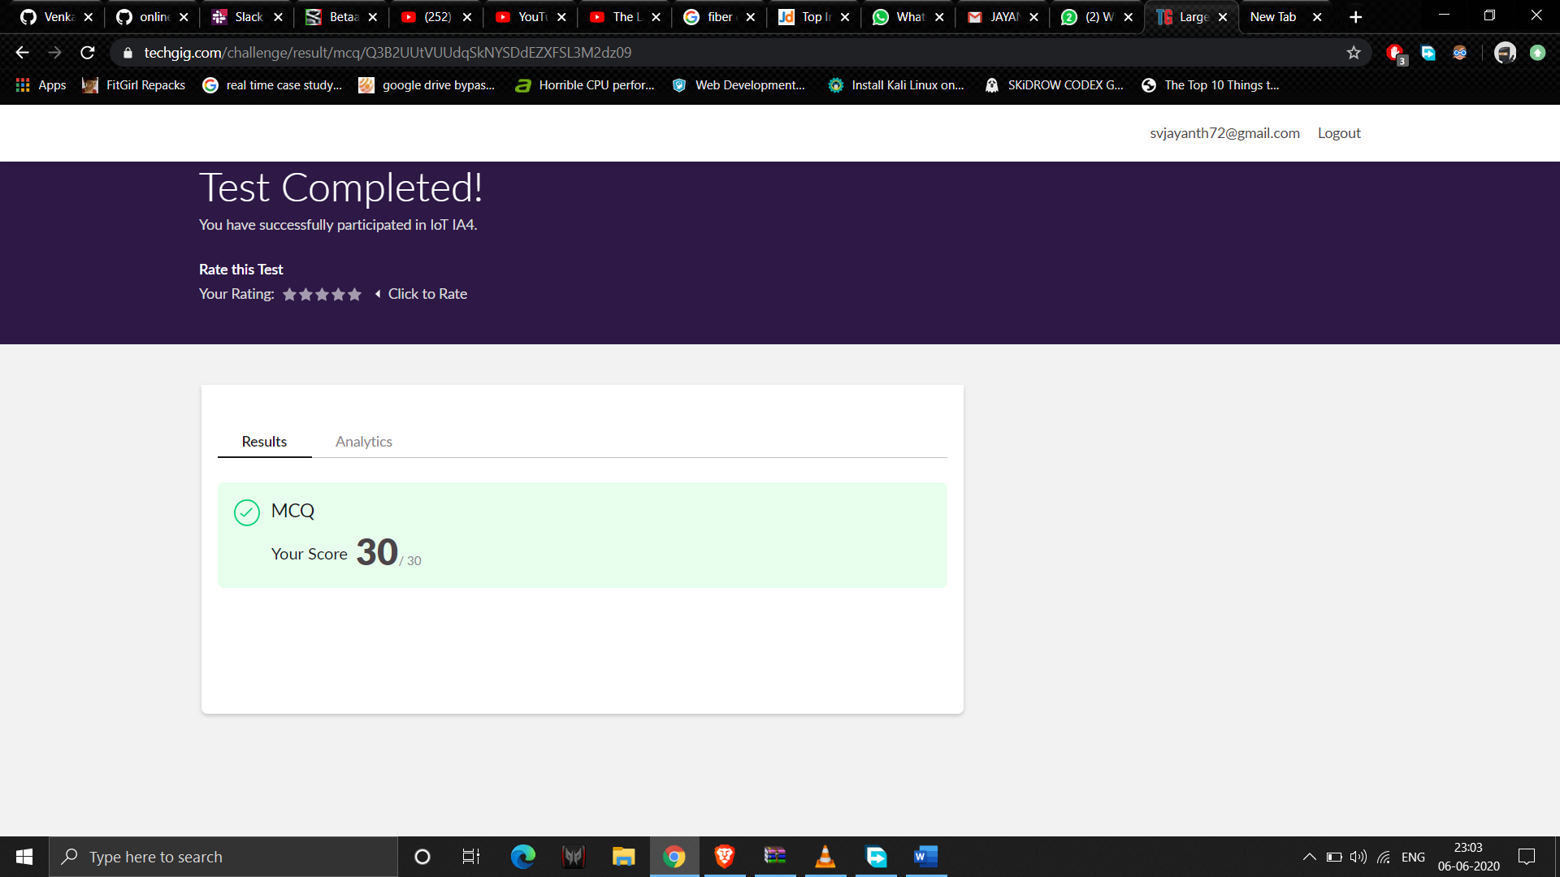

Coding Challenges Details:

|  |
| --- |
|  |
|  |
|  |
|  |
|  |
|  |
|  |
|  |
|  |
|  |
|  |
|  |
|  |
|  |
|  |
|  |
|  |
|  |
|  |
|  |
|  |
|  |
|  |
|  |
|  |
|  |
|  |
|  |
|  |
|  |
|  |
|  |
|  |
|  |
|  |
|  |
|  |
|  |
|  |
|  |
|  |
|  |
|  |
|  |
|  |
|  |
|  |
|  |
|  |
|  |
|  |
|  |
|  |
|  |

**Program1:**

**#include <stdio.h>**

**void leftRotatebyOne(int arr[], int n);**

**void leftRotate(int arr[], int d, int n)**

**{**

**int i;**

**for (i = 0; i < d; i++)**

**leftRotatebyOne(arr, n);**

**}**

**void leftRotatebyOne(int arr[], int n)**

**{**

**int temp = arr[0], i;**

**for (i = 0; i < n - 1; i++)**

**arr[i] = arr[i + 1];**

**arr[i] = temp;**

**}**

**void printArray(int arr[], int n)**

**{**

**int i;**

**for (i = 0; i < n; i++)**

**printf("%d ", arr[i]);**

**printf("\n");**

**}**

**int main()**

**{**

**int n,d;**

**printf("Enter the size of array : ");**

**scanf("%d",&n);**

**int arr[n];**

**printf("\nEnter the array elements :\n");**

**for(int i=0;i<n;i++)**

**scanf("%d",&arr[i]);**

**printf("Enter the Position N from where you want to**

**rotate : ");**

**scanf("%d",&d);**

**leftRotate(arr, d, n);**

**printArray(arr, n);**

**return 0;**

**}**